EVAN BROWN – Final project checkpoint 1
https://github.com/EvanBrown-Git/Portfolio-Work/tree/main/scenes/Roman%20gladiator%20Room
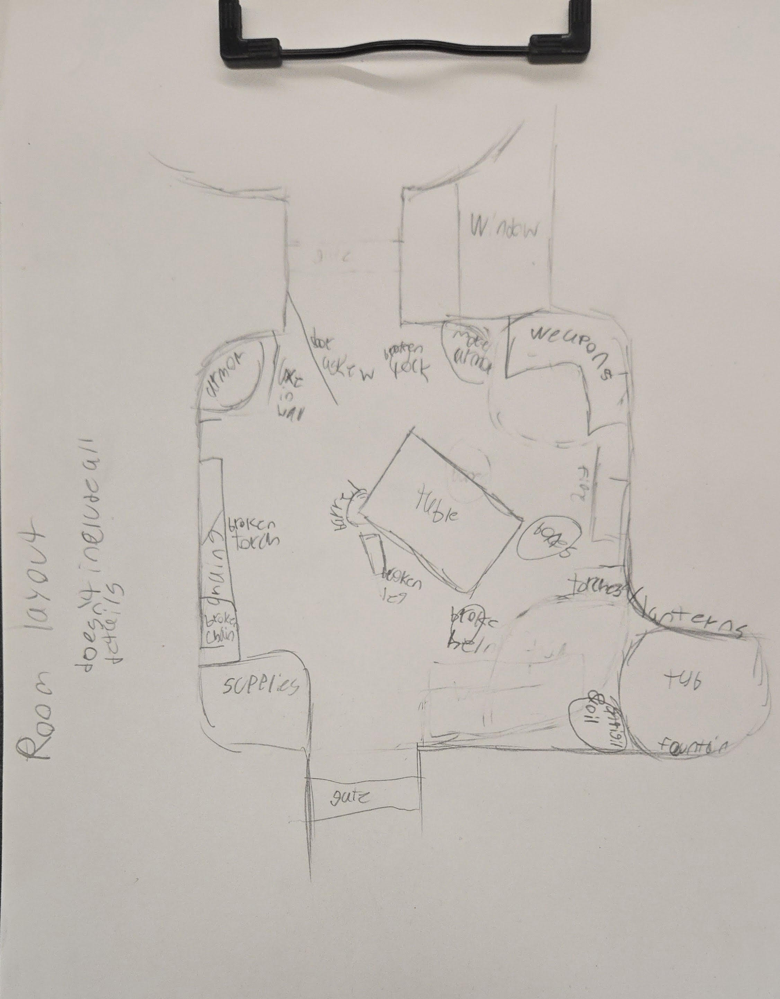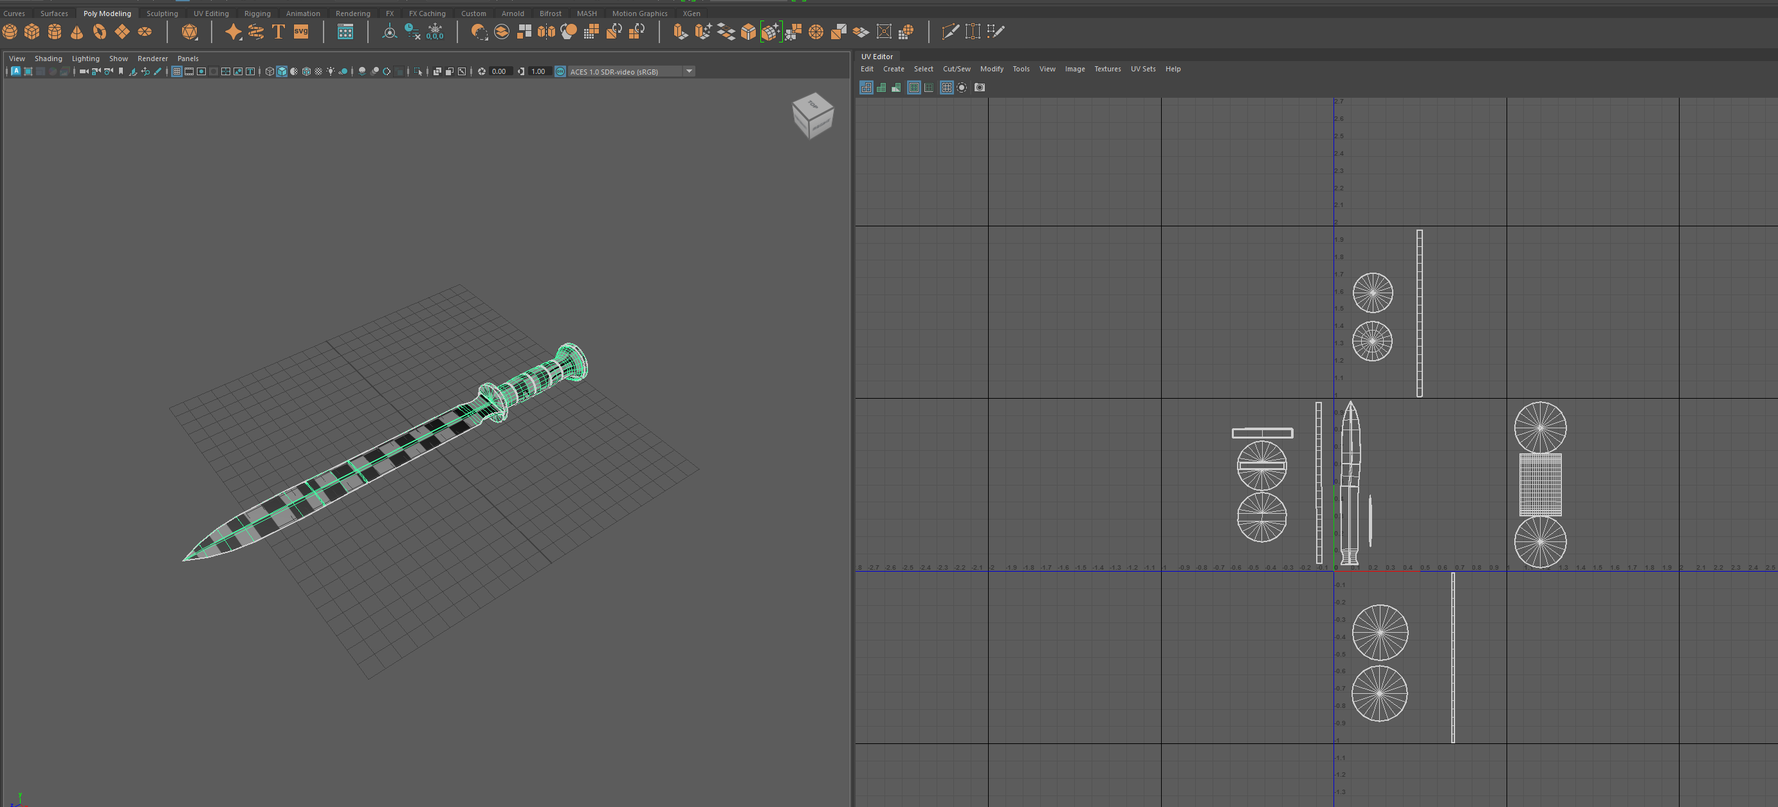
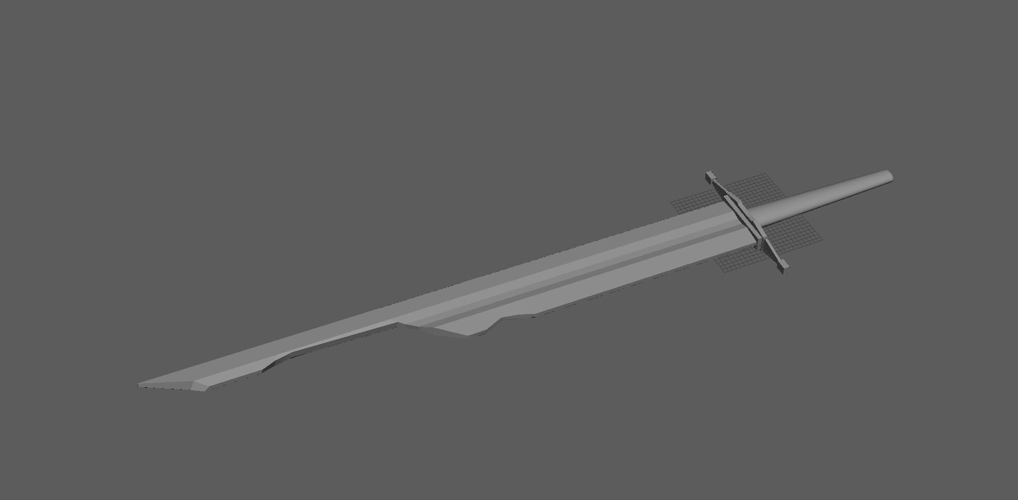
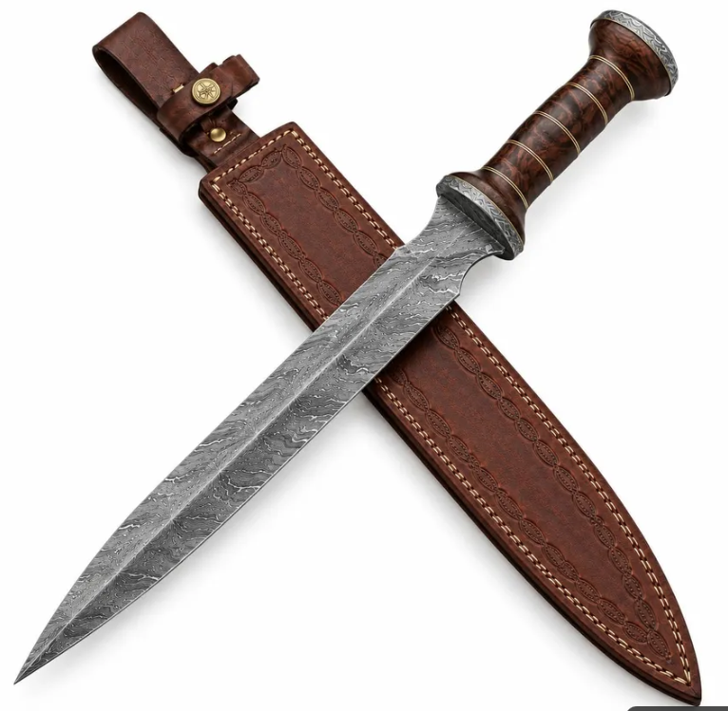
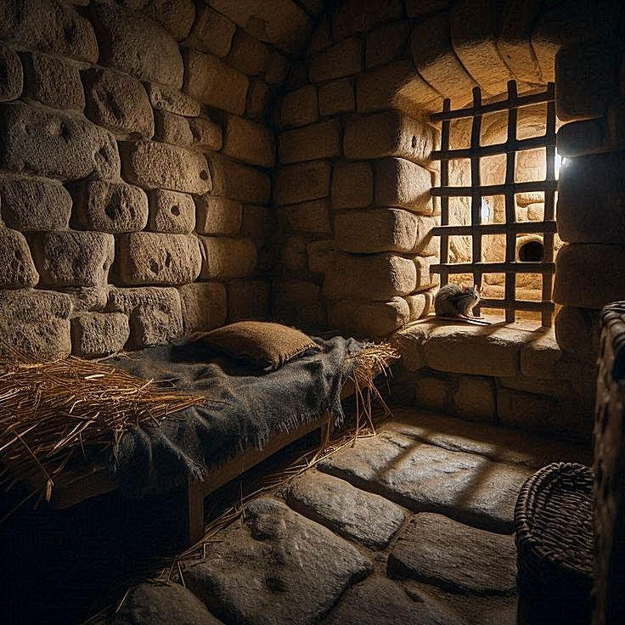
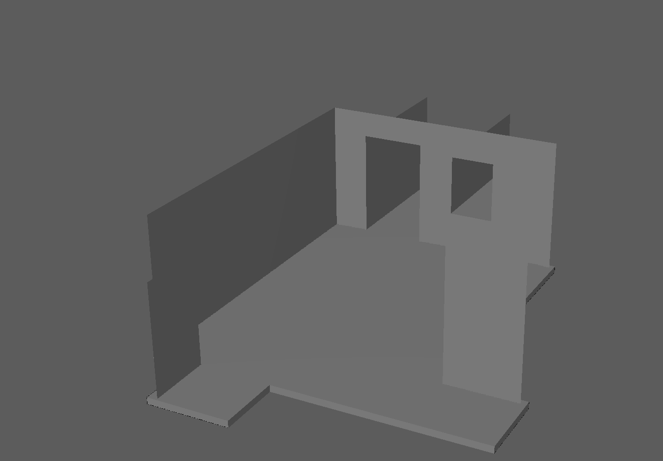

I went to pinterest for references and here’s what I found:
Room : https://github.com/EvanBrown-Git/Portfolio-Work/tree/main/Refs/Images/Roman%20gladiator%20room/Room%20vibe
Room features : https://github.com/EvanBrown-Git/Portfolio-Work/tree/main/Refs/Images/Roman%20gladiator%20room/Room%20features
Props : https://github.com/EvanBrown-Git/Portfolio-Work/tree/main/Refs/Images/Roman%20gladiator%20room/Props
Weapons : https://github.com/EvanBrown-Git/Portfolio-Work/tree/main/Refs/Images/Roman%20gladiator%20room/Weapons

I did some research on ancient roman washing traditions as I’m going to have a shower-esque portion of my scene and I learnt that ancient romans would rub olive oil into their skin and then use a device called a strigil to scrape it off along with the dirt, so I’m going to add those. I modeled the gladius from the reference material (still need to made the sheath) and I modeled the oil bottle. I blocked out the rough shape of the room (backface culling makes it look weird), the broken claymore, and the strigil. I’m planning on adding weapons from different cultures to show that they gathered them from defeated enemies.
I also sketched out a rough layout to show how I’m planning on arranging things (not an actual reference, more of a guide)

